**BANK LOAN REPORT QUERY DOCUMENTS**

* **SQL**

1. **Total Loan Application**

select COUNT(id) As Total_loan_Application from Bank_Loan_data



1. **MTD Total Loan Application**

select COUNT(id) As MTD_Total_loan_Application from Bank_Loan_dataT

where MONTH (issue_date ) = 12 AND YEAR ( issue_date) = 2021



1. **PMTD Total Loan Application**

SELECT COUNT (id) AS PMTD_Total_Loan_Application FROM Bank_loan_data

WHERE MONTH (issue_date) = 11 AND YEAR (issue_date) = 2021



1. **Total Funded Amount**

select sum ( loan_Amount ) as Total_Funded_Amount from Bank_loan_data



1. **MTD_Total_Funded_Amount**

select sum ( loan_Amount ) as MTD_Total_Funded_Amount from Bank_loan_data

where MONTH (issue_date) = 12 and YEAR (issue_date) = 2021



1. **PMTD_Total_Funded_Amount**

select sum ( loan_Amount ) as PMTD_Total_Funded_Amount from Bank_loan_data

where MONTH (issue_date) = 11 and YEAR (issue_date) = 2021



1. **Total_Amount_Recived**

SELECT SUM (total_payment) as Total_Amount_Recived from Bank_Loan_data



1. **MTD_Total_Amount_Recived**

SELECT SUM (total_payment) as MTD_Total_Amount_Recived from Bank_Loan_data

where MONTH (issue_date) = 12 and YEAR (issue_date ) = 2021



1. **PMTD_Total_Amount_Recived**

SELECT SUM (total_payment) as PMTD_Total_Amount_Recived from Bank_Loan_data

where MONTH (issue_date) = 11 and YEAR (issue_date ) = 2021



1. **Avg_Interest_Rate**

select AVG (Int_rate) * 100 As Avg_Interest_Rate from Bank_Loan_data



1. **MTD_Avg_Interest_Rate**

select AVG (Int_rate) * 100 As MTD_Avg_Interest_Rate from Bank_Loan_data

where MONTH(issue_date) = 12 And YEAR (issue_date) = 2021



1. **PMTD_Avg_Inerest_Rate**

select AVG (Int_rate) * 100 As PMTD_Avg_Interest_Rate from Bank_Loan_data

where MONTH(issue_date) = 11 And YEAR (issue_date) = 2021



1. **Avg_DTI**

select AVG(dti) * 100 As Avg_DTI from Bank_Loan_data



1. **MTD_Avg_DTI**

select AVG(dti) * 100 As MTD_Avg_DTI from Bank_Loan_data

where MONTH(issue_date) = 12 and YEAR (issue_date ) = 2021



1. **PMTD_Avg_DTI**

select AVG(dti) * 100 As PMTD_Avg_DTI from Bank_Loan_data

where MONTH(issue_date) = 11 and YEAR (issue_date ) = 2021



1. **Good_Loan_Percentage**

SELECT

(COUNT (CASE WHEN loan_status = 'Fully Paid' OR loan_status = 'Current' THEN id END)* 100)

/

COUNT (id) AS Good_Loan_Percentage

FROM Bank_Loan_Data



1. **Good_Loan_Application**

SELECT COUNT(id) AS Good_Loan_Application FROM Bank_Loan_Data

WHERE Loan_status = 'Fully Paid' OR loan_status = 'Current'



1. **Good_Loan_Funded_Amount**

SELECT SUM (loan_amount) AS Good_Loan_Funded_Amount FROM Bank_Loan_Data

WHERE Loan_status = 'Fully Paid' OR loan_status = 'Current'



1. Good_Loan_Recived_Amount

SELECT SUM (total_payment) AS Good_Loan_Recived_Amount FROM Bank_Loan_Data

WHERE Loan_status = 'Fully Paid' OR loan_status = 'Current'



1. **Bad_Loan_Percentage**

SELECT

(COUNT (CASE WHEN loan_status = 'Charged OFF' THEN id END )* 100.0)/

COUNT(id) AS Bad_Loan_Percentage

FROM Bank_Loan_Data



1. **Bad_Loan_Application**

SELECT COUNT(id) AS Bad_Loan_Application FROM Bank_Loan_Data

WHERE Loan_status = 'Charged OFF'



1. **Bad_Loan_funded_Amount**

SELECT SUM (loan_amount) AS Bad_Loan_Funded_Amount FROM Bank_Loan_Data

WHERE Loan_status = 'Charged OFF'



1. **Bad_ Loan_Amount_Recived**

SELECT SUM (total_payment) AS Bad_Loan_Amount_Recived FROM Bank_Loan_Data

WHERE Loan_status = 'Charged OFF'



1. **Loan_Status**

SELECT

loan_status,

COUNT (id) AS Total_loan_Application,

SUM (total_payment) AS Total_Amount_Recived,

SUM ( loan_amount ) AS Total_Funded_Amount,

AVG (int_rate * 100 ) AS Interest_Rate,

AVG ( dti * 100 ) AS DTI

FROM

Bank_Loan_Data

GROUP BY

loan_status

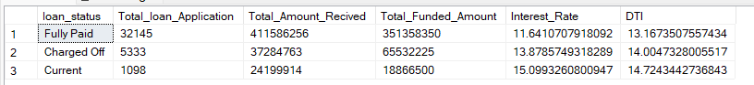

25) Loan Status

select

loan_status,

sum (total_payment) AS MTD_Total_Amount_Recived,

sum (loan_amount ) AS MTD_Total_Funded_Amount

from Bank_Loan_Data

where Month (issue_date) = 12

group by loan_status

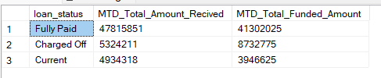

**DASHBOARD 2 - OVERVIEW**

1. **MONTHLY TRENDS BY ISSUE DATE**

SELECT

MONTH( issue_date ) AS Month_Number,

DATENAME( MONTH, issue_date ) AS Month_Name,

COUNT(id) AS Total_Loan_Application,

SUM( loan_amount) AS Total_Funded_Amount,

SUM( total_payment ) AS Total_Recived_Amount

FROM Bank_Loan_Data

GROUP BY MONTH ( issue_date ), DATENAME (MONTH, issue_date)

ORDER BY MONTH ( issue_date )

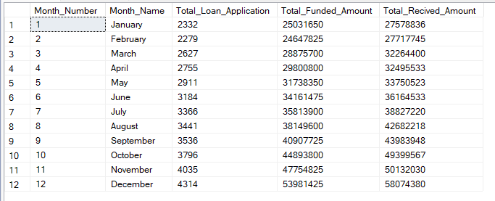

1. **REGIONAL ANALYSIS BY STATE**

SELECT

Address_state,

COUNT(id) AS Total_Loan_Application,

SUM( loan_amount) AS Total_Funded_Amount,

SUM( total_payment ) AS Total_Recived_Amount

FROM Bank_Loan_Data

GROUP BY Address_state

ORDER BY Address_state

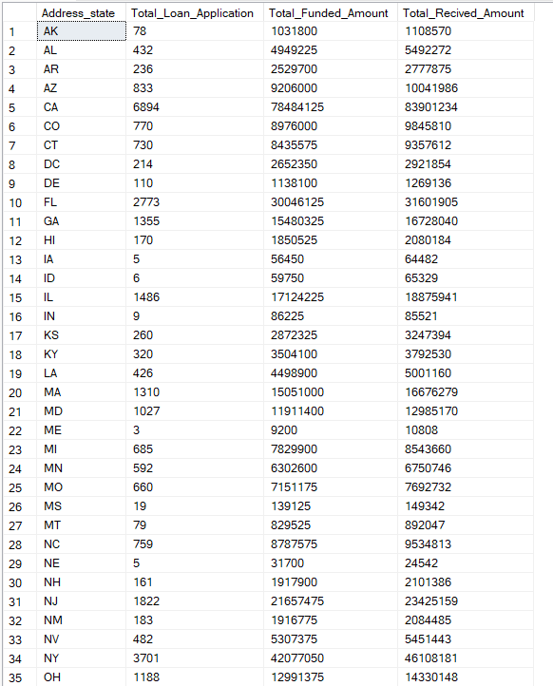

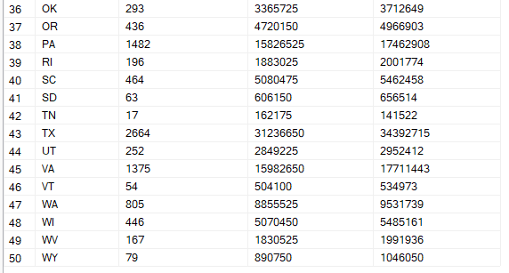

3**) Term**

SELECT

term,

COUNT(id) AS Total_Loan_Application,

SUM( loan_amount) AS Total_Funded_Amount,

SUM( total_payment ) AS Total_Recived_Amount

FROM Bank_Loan_Data

GROUP BY term

ORDER BY term

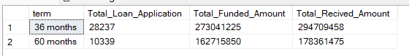

**4) Employee_ Length**

SELECT

emp_length,

COUNT (id) AS Total_Loan_Application,

SUM ( loan_amount) AS Total_Funded_Amount,

SUM ( total_payment ) AS Total_Recived_Amount

FROM Bank_Loan_Data

GROUP BY emp_length

ORDER BY COUNT (id)

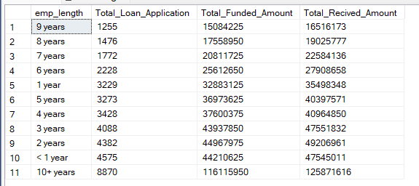

**5) Purpose**

SELECT

purpose,

COUNT (id) AS Total_Loan_Application,

SUM ( loan_amount) AS Total_Funded_Amount,

SUM ( total_payment ) AS Total_Recived_Amount

FROM Bank_Loan_Data

GROUP BY purpose

ORDER BY COUNT (id)

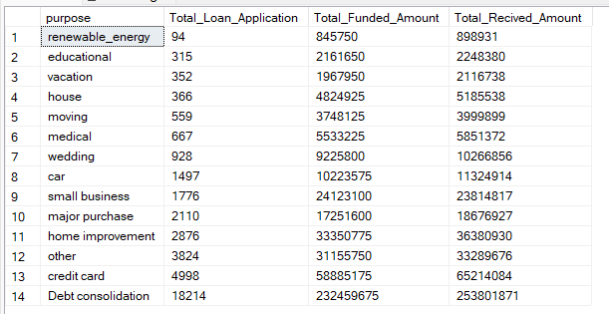

**6) Home Ownership**

SELECT

home_ownership,

COUNT (id) AS Total_Loan_Application,

SUM ( loan_amount) AS Total_Funded_Amount,

SUM ( total_payment ) AS Total_Recived_Amount

FROM Bank_Loan_Data

GROUP BY home_ownership

ORDER BY COUNT (id)

